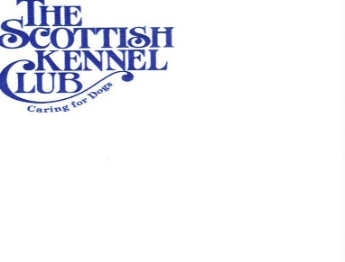
SCOTTISH KENNEL CLUB 2021 CHAMPIONSHIP SHOW
ROYAL HIGHLAND SHOWGROUND, INGLISTON, EDINBURGH
30TH SEPTEMBER – 3RD OCTOBER 2021
TRACK AND TRACE FORM

DATE PARTICIPATING AT EVENT: THURS 30TH SEPT / FRI 1ST OCT / SAT 2ND OCT / SUN 3RD OCT
(PLEASE CIRCLE)

NAME: ……………………………………………………………………………………………………

TELEPHONE NUMBER: ………………………………………………………………………………………

POSTCODE: ………………………………………………………………………………………………….

